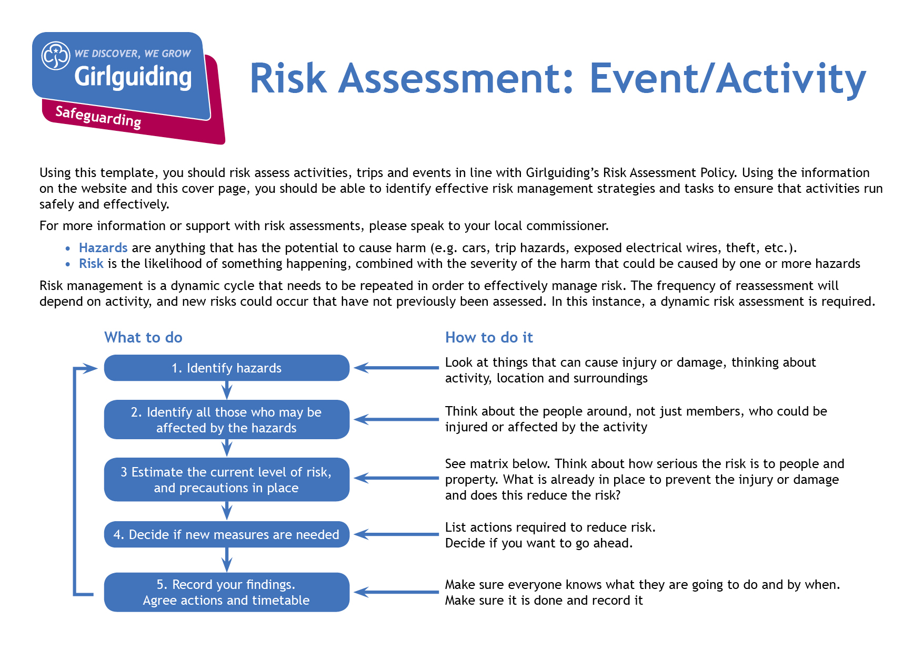
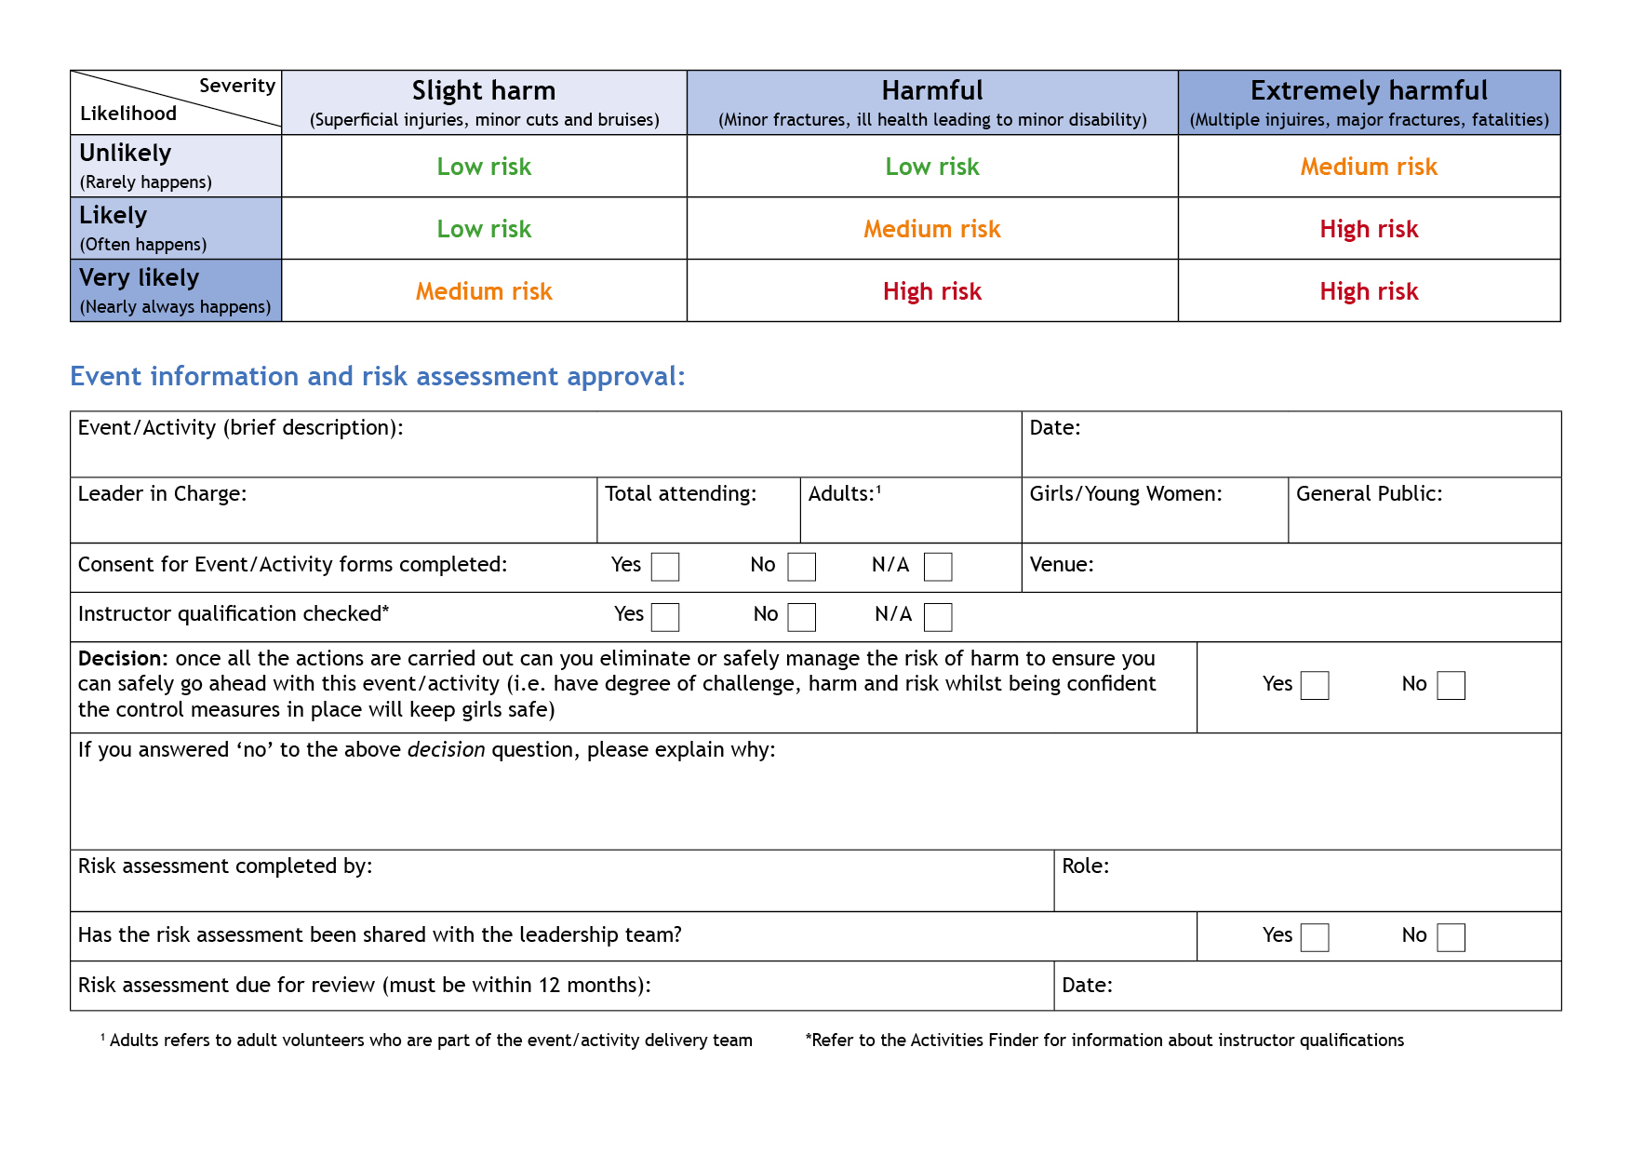
Hazards  What could cause harm or damage? | Who or what is at risk of being affected and how? | What are you already doing?  How have you reduced the risk already? | Likelihood of risk occurring  (L/M/H) | Severity of risk  (L/M/H) | Are further controls necessary?  What else needs to happen to reduce the risk to an acceptable level? | Action by:  name/date
Nettle stings  Thorns  Scratches  Trees | Anybody outside | 1.Nettles, thorns to be cut back regularly.  2.Trees checked regularly by warden. | L | M | Children to be briefed about:- where not to go, told to be careful, and who to go to in case of injury. | Leaders
Moving vehicles | Anybody in the playground |  | L | H | 1. Children must be supervised when outside.  2. Gates to be kept shut when children are in the playground. | Leaders
Strangers entering the playground or house. | Anybody |  | L | L | 1. Children must be supervised at all times when outside. 2. Ensure main entrance door is closed. | Leaders
Fire. | Anybody | 1.All fire instructions given in house information and policy. 2.Evacuation designated area sign posted.  3. Sign on gate advising 24 hours access required.  4. All house electrical items have annual PAT. | L | H | 1. Hold fire drill on arrival. 2. Familiarize yourself with the house fire points, extinguishers ,fire blankets. 3. Fire doors must be kept closed. 4. Keep gate clear at all times for emergency vehicles. 5. All electrical charges must be switched off and unplugged at night. 6. Plug sockets not to be overloaded. 7. Electrical extensions should be fully unwound before use. | Leaders
Risk of injury from tripping. | Anybody | Uneven floor in main room please beware. | L | L | 1.Keep all areas tidy especially the entrances:- tidy boots/shoes. 2. Wires from electric appliances must be placed carefully. | Leaders
Broken glass. | Anybody |  | L | L | No hard ball games inside the house. | Leaders
Slipping and Illness | Anybody | Mats provided to be used in the showers | M | M | 1.Instruct everyone not to run in the washrooms and water on floors to be cleaned up immediately.  2. Washroom, showers and wet room to be checked and cleaned regularly. | Leaders

Hazards  What could cause harm or damage? | Who or what is at risk of being affected and how? | What are you already doing?  How have you reduced the risk already? | Likelihood of risk occurring  (L/M/H) | Severity of risk  (L/M/H) | Are further controls necessary?  What else needs to happen to reduce the risk to an acceptable level? | Action by:  name/date
Risk of injury from falling. | Anybody | 1. Sleeping bags on top not advisable, children to be instructed to stay out of the bedroom during the day time. 2. When using high steps always ensure two persons are available one must steady the steps whilst other uses them. 3.Climbing frame to be checked regularly by warden | L | M | 1. Children must be supervised at all times in the dormitory if awake.  2. Children must be briefed not to stand or jump on bunk beds and shown how to use the ladders properly. 3. Children must be supervised when using climbing frame. | Leaders
Poisoning. | Anybody | All COSHH related items such as cleaning materials, and chemicals are locked in the caretaker’s cupboard. | L | H | 1.Keep all medicines in a locked container.  2. Take any left over COSHH related items brought into house home when leaving. | Leaders
Cuts burns and scolds. | Anybody | First aid kit is sited in the kitchen. | L | M | 1.Children to be supervised in the kitchen and shown how to use knives, sharp utensils and appliances safely. | Leaders
Contamination of food  (food poisoning). | Anybody | Food hygiene guidelines to be adhered to. | L | L | Children to be reminded to wash their hands ,tie hair back and wear aprons. | Leaders
Tables and chairs. | Anybody | Tables and chairs to be stacked properly (no more than 8 high). | L | M | No sitting on tables and stacked chairs. | Leaders
Children leaving the premises unsupervised during night time. | Children | Door alarms in leaders bedroom. | L | H | Door alarms to be switched on at bedtime only. | Leaders
Air-born Viruses – (such as Covid). | Anybody | 1.Hand sanitizer provided.  2. A Covid first aid box is sited in the first aid room which you may use. | M | L | 1.Be Covid responsible when using the house. 2.Clean touch points regularly. 3.Allow space and ventilate house as much as possible. 4. Regular hand washing. 5. All attendees should notify leader in charge of any illnesses before arrival. | Leaders

